From the Membership Director – Paul Barnes PMP

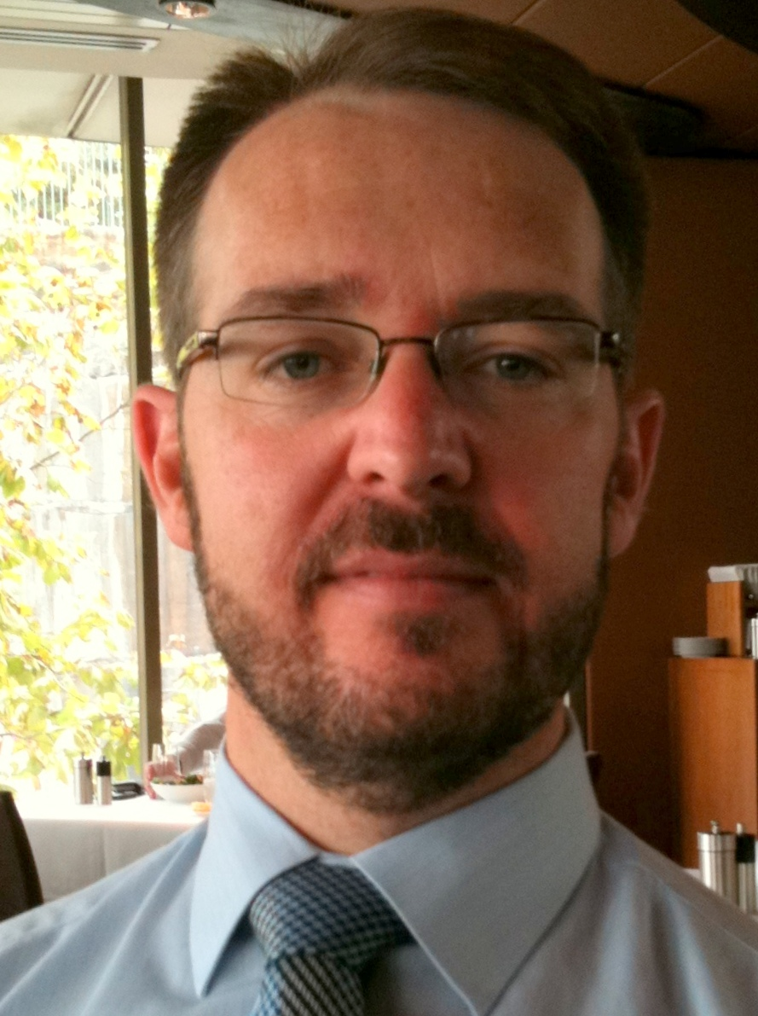
Firstly, I would like to say a big thank you to Venesa, who held the Membership Directorship last year, in what many would agree were challenging circumstances to say the least. Even with a busy schedule and a baby due soon, she found time to sit with me as part of a pre-handover meeting to ensure I can hit the ground running and ask any questions before it is too late!

From my early days, I have seen that Directors can’t work in isolation. Just like in projects, we all need to work as a team to ensure we deliver the best results. With a fantastic team this year, we should have an exciting and successful 2013.

On that note, I hope you all enjoyed a well-deserved break and are re-energised for a prosperous new year. I look forward to meeting you at the next chapter meeting – come and introduce yourself!

